* **Work**

1. First Install Jenkins
2. Create a Kubernetes Cluster
3. Set up Jenkins server to deploy Applications in K8 cluster
4. Build and Deploy docker Applications from Jenkins into K8 cluster using CI/CD Pipeline

* **Flow**

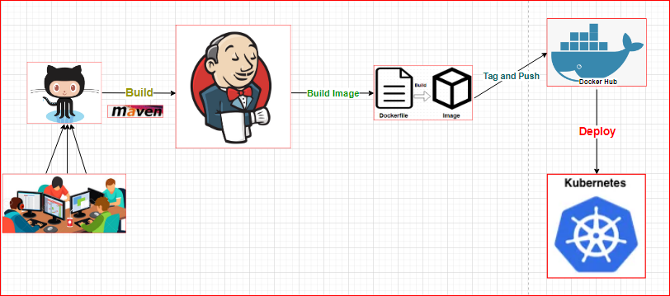

* **Resources required on AWS Management console**

1. Jenkins Server [Prefer machine size - t2.medium]
2. K8 Cluster [Mandatory t2.medium for Master and OK t2.micro for Slave]

* **PREREQUISITE**
* Install Jenkins + GIT + Maven + Java + Docker + Kubelet on Ubuntu Server(Jenkins Server)
* Set up the k8 Cluster(1 Master[t2.medium] + 1 Worker[t2.micro]) as per below commands attached in the text pad
* **Need a code repository from Github –**

[*https://github.com/mhali922/jenkins-docker-k8.git*](https://github.com/mhali922/jenkins-docker-k8.git)

The above repo contains the Docker file + Pom.xml + Java code + code for Jenkins pipelines that needs to be written into Jenkins while creating a Pipeline.

**Manual:**

1. **INSTALL JENKINS –**

* **First Install Java**
* sudo apt update
* sudo apt install openjdk-8-jdk
* **Install Jenkins**
* wget -q -O - http://pkg.jenkins-ci.org/debian/jenkins-ci.org.key | sudo apt-key add –
* sudo sh -c 'echo deb http://pkg.jenkins-ci.org/debian-stable binary/ > /etc/apt/sources.list.d/jenkins.list'
* sudo apt update
* sudo apt install Jenkins
* sudo systemctl status Jenkins

**### Additionally, I am installing kubectl CLI on Jenkins server in order to talk to K8 cluster –**

* *1 - sudo apt-get update -y*
* *2 - sudo apt-get install -y apt-transport-https*
* *3 - curl -s https://packages.cloud.google.com/apt/doc/apt-key.gpg | apt-key add -*
* *4 – echo “deb http://apt.kubernetes.io/ kubernetes-xenial main” | sudo tee –a /etc/apt/sources.list.d/kubernetes.list*
* *5 – sudo apt-get update*
* *6 - sudo apt-get install -y kubectl*
* Make sure switch to Jenkins user by *sudo -i -u Jenkins*
* Go to home dir - *cd ~*
* Create a new directory using *mkdir .kube*
* Create a config file and copy config file contents to this config file – *vi .kube/config*

After the installation of Jenkins at Ubuntu server, access Jenkins from web-browser using server’s PUBLIC IP address –

* **Setting up Docker on Jenkins Server –**
* Install Docker
* *curl –fsSL get.docker.com | /bin/bash*
* Add Jenkins user to docker group
* *sudo usermod –aG docker Jenkins*
* Restart Jenkins
* *sudo systemctl restart jenkins*

1. **Setup Kubernetes cluster as per below commands –**

**Execute below commands on both Master-Slave -**



**Make sure the security groups open for All traffic in AWS SG as per below screen -

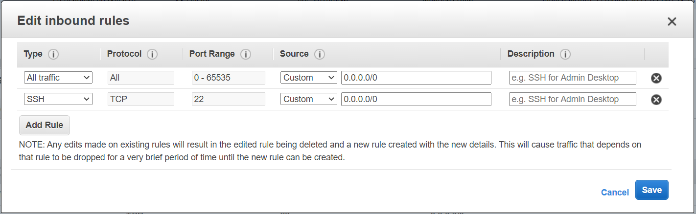

1. **Set up Jenkins server to deploy Applications at K8 cluster**
2. Need to install Plugins –

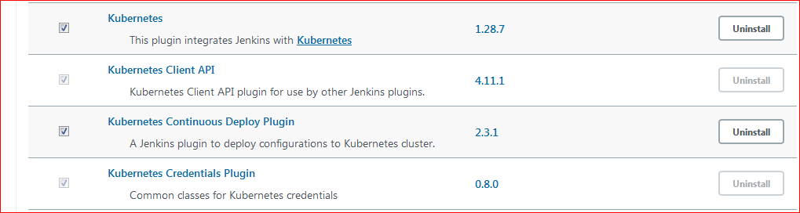

1. Setup into Manage Credentials @ Jenkins –

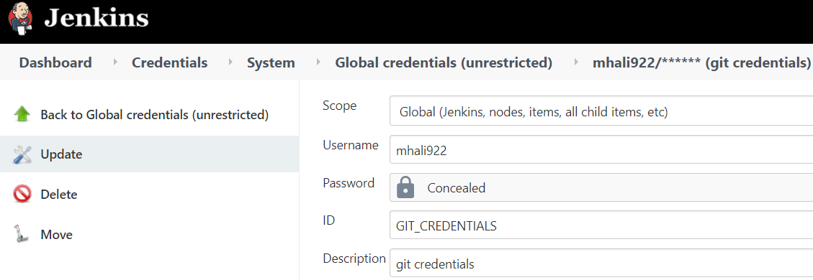

1. Set up Credentials for Jenkins + K8 handshake –

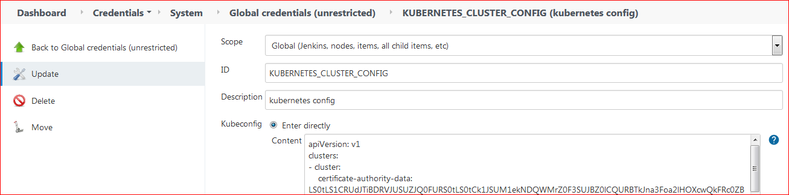

1. **Build and Deploy docker Applications from Jenkins into K8 cluster using CI/CD Pipeline**

* We all set to finally creating a pipeline do a CI/CD through Pipeline

**~~Rough -~~**

**Global Tool Configurations -**

